# State Space Model

## Introduction

In this report, state-space model of 3 phase voltage inverter with rectifier is investigated. State variable selections and mathematical idea of model are argued. Inverter and rectifier are split in two different state space model and the combination of two state space is shown. Also, results are compared with Simulink model of 3-phase inverter and the reliability of the state space model is discussed.

## 3-Phase Voltage Inverter

At this part, the rectifier circuit is taken as an ideal voltage source and the state space representation of 3-phase inverter is created.

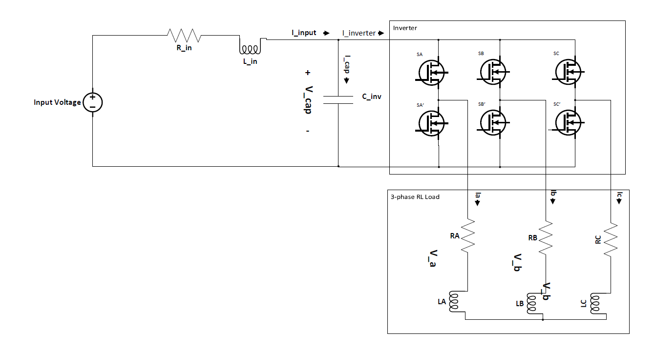

Figure 1 Three Phase Inverter

Figure 1 shows the circuit schematic of the 3-phase inverter. There are 3 half-bridge legs and Top and Bottom transistors in each leg are driven in complement way. Thus, 6 transistors are driven by switching functions which is derived from one switching functions with phase differences and complementariness.

Each switching functions has DC, fundamental, switching and side band harmonics shown at equation 1. However, we are not interested in all of components which is hard to calculate. The switching functions is given as ‘1’ and ‘0’ with respect to transistor is on-conduct or not. Actually, if the top transistor at phase A is on conduction, SA is given as ‘1’ and phase A current pass through this transistor.

Switching Function = $\frac{1}{2}+\frac{M}{2}\cos\left(w_{o}+θ_{o} \right)+\sum_{m=1}^{∞}{\frac{2}{π}J_{o}\left(\frac{mπM}{2}\right)\sin\left(\frac{mπ}{2}\right)\cos\left(m\left(w_{c}+θ_{c}\right)\right)}$

$\sum_{m=1 }^{∞}{\sum_{n=-∞}^{∞}{\frac{2}{π}\frac{1}{m}J_{n}(\frac{mMπ}{2})sin⁡(\frac{\left(m+n\right)π}{2})cos⁡(m\left(w_{c}+θ_{c}\right)+n(w_{o}+θ_{o}))}}$ (1)

State space representation is a mathematical model of physical system. At system, there are some variables called state variable which value at present can be calculated by other past state variables values and input values. As can be seen at equation

$$\frac{dX}{dt}=AX+BU ==>X_{k+1}=AX_{k}+BU_{k+1}$$

Table 1 State Space Parameters

|  |  |
| --- | --- |
| Parameter | Type |
|  |  |
|  |  |
|  |  |
|  |  |
|  |  |
|  |  |
|  |  |